LAB REPORT
ON

GET ACQUAINTED WITH DATA SCIENCE TOOLS AND PERFORM STATISTICAL ANALYSIS

FOUNDATION OF DATA SCIENCE

BY
SHANDES BAASNET
PUR080BCT084


To
ER. SUJAN KARKI

TRIBHUVAN UNIVERSITY
INSTITUTE OF ENGINEERING

DEPARTMENT OF ELECTRONICS AND COMPUTER ENGINEERING
PURWANCHAL CAMPUS
DHARAN, NEPAL

Lab 1
- Get acquainted with data science tools and perform statistical analysis
1.1 Objective
-To familiarize yourself with essential tools and libraries used in data
science.
-To learn to describe data using descriptive statistics.

1.2 Theory
- Python
Python is a high-level and widely used programming language for data science due to its simplicity and rich ecosystem of libraires. Its popular libraries include Pandas, NumPy, Scikit-learn, Matplotlib, Seaborn, etc. Python is used for data manipulation, visualization, machine learning, and automation.

- Anaconda
Anaconda is a distribution of the Python and R programming languages for scientific computing (data science, machine learning applications, large-scale data processing, predictive analytics, etc.), that aims to simplify package management and deployment.

- Jupyter Note Book
The Jupyter Notebook is an open-source web application that allows you to create and share documents that contain live code, equations, visualizations,and narrative text. Its uses include data cleaning and transformation, numerical simulation, statistical modelling, data visualization,machine learning, and much more.

- NumPy
NumPy is a Python library used for working with arrays. It also has functions for working in domain of linear algebra, Fourier transform, and matrices. NumPy, stands for Numerical Python, is used for the manipulation of elements of numerical array data.

- SciPy
SciPy is a scientific computation library that uses NumPy underneath. SciPy stands for Scientific Python. It provides more utility functions for optimization, stats and signal processing. Like NumPy, SciPy is open source so we can use it freely. SciPy, stands for Scientific Python, is used for numerical computations in Python. Both these packages provide extended functionality to work with Python.

- Stats models
Stats models is a popular library in Python that enables us to estimate and analyse various statistical models. It is built on numeric and scientific libraries like NumPy and SciPy. It includes various models of linear regression like ordinary least squares, generalized least squares, weighted least squares, etc

- Pandas
Pandas are really powerful. They provide you with a huge set of important commands and features which are used to easily analyse your data. We can use Pandas to perform various tasks like filtering your data according to certain conditions, or segmenting and segregating the data according to preference, etc.

- Matplotlib
Matplotlib is Python library used for creation static, interactive, and animated visualizations. It provides a variety of plotting options, such as line plots, bar charts, scatter plots, and histograms. Matplotlib is highly customizable and serves as the foundation for other visualization libraries like Seaborn.

- Seaborn
Seaborn is a Python library built on Matplotlib, designed to simplify the creation of visually appealing and informative statistical graphics. It includes features like heatmaps, violin plots, pair plots, and categorical plots. Seaborn integrates seamlessly with Pandas, making it ideal for exploratory data analysis.

- Scikit-learn
Scikit learn is a powerful machine- learning in Python that provide stools for supervised and unsupervised learning, such as regression, classification, clustering, and dimensionality reduction. It also includes utilities for model selection, pre-processing, and evaluation. Scikit-learn is built on NumPy, SciPy, and Matplotlib.

- Google Colab
Google Colab is a cloud-based platform for running Python code, offering free GPU and TPU resources. It supports popular data science libraries like TensorFlow, PyTorch, Pandas, and NumPy. Google Colab is commonly used for machine learning, data analysis, and collaborative projects.

Descriptive statistics

Descriptive statistics is a branch of statistics that focuses on summarizing and organizing data to uncover patterns, relationships, and trends. It provides a foundation for data analysis by offering methods to describe and present data meaningfully.

Types of Descriptive statistics:
- Measures of Central Tendency: Central tendency provides a single value that represents the centre or typical value of a dataset.
Mean (Average): The sum of all data points divided by the total number of points.
Median: The middle value of an ordered dataset. It is less sensitive to outliers.
Mode: The value that appears most frequently in a dataset.

- Measures of Dispersion (Spread): Dispersion measures how spread out
the data values are around the central tendency.
Range: The difference between the maximum and minimum values.
Variance: The average squared deviation from the mean.
Standard Deviation: The square root of the variance, showing how data
points deviate from the mean.
Inter-quartile Range (IQR): The range of the middle 50% of the data,
calculated as Q3 - Q1

- Measures of Shape: These metrics describe the distribution and symmetry
of the data.
Skewness: Measures asymmetry. Positive skew indicates a longer tail on
the right; negative skew indicates a longer tail on the left.
Kurtosis: Measures the "tailed ness" of the distribution. High kurtosis
means heavy tails; low kurtosis means light tails.

  - Installing Process

Download Anaconda:
Step1: Search “Anaconda Download” in Browser.
Step 2: Provide you email to get link for downloading or you can skip registration to Download
Step 3: Click skip registration to go to download page. Click 64 bit install according to your OS.
Step 4: Open the downloaded exe file and install anaconda on your pc according to your preferences.
Step 5: After installing anaconda scroll down and search Jupyter notebook, and if not installed then install it and launch it
Step 6: Jupyter notebook will open on your browser. Then click on new and click Python3
Step 7: Write your code and run it. Shortcut is (SHIFT+ENTER).

Installing Packages:
Step 1: Go to the folder annoconda on your start menu and open “Annoconda Prompt”.
Step 2: Installing
->Confirm Python is installed correctly, by typing “python -V”.
->Confirm conda is installed properly, by typing “condda -V”.
->You can install packages using pip or conda “pip(conda) install<package_name>”

- For installing particular version of a package
“pip install <package_name>=package_version”

- For installing multiple packages all at once
”pip install <package_name1> <package_name2> <package_name3>”

- For updating package “pip install --upgrade <package_name>”

- For installing libraries for data-science
“pip install numpy scipy stats models pandas seaborn matplotlib scikit-learn”
OR
“conda install numpy scipy statsmodels pandas seaborn matplotlib
scikit-learn”

Access Google Colab
1. Visit https://colab.research.google.com/ and sign in with your Google account.
2. Create a new notebook by clicking on "New Notebook".

In this lab we will be using Google Colab.

1.4 Colab File:
Screenshots of the data is below:

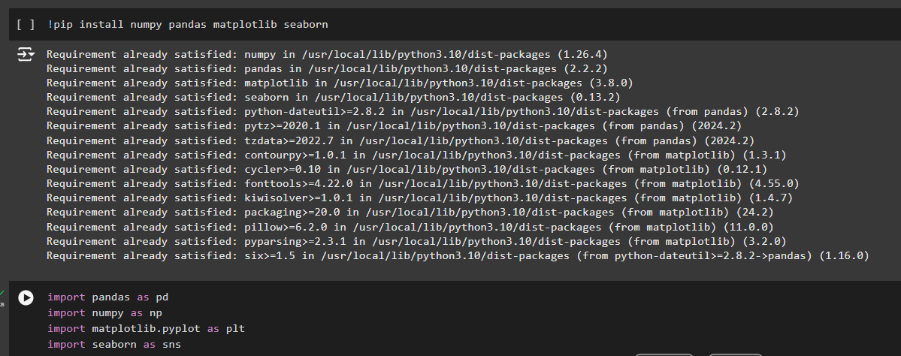

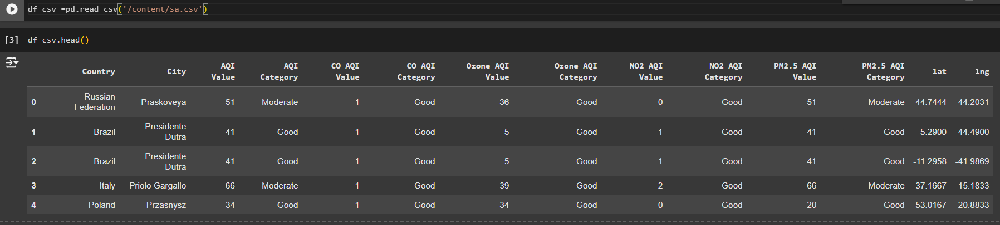

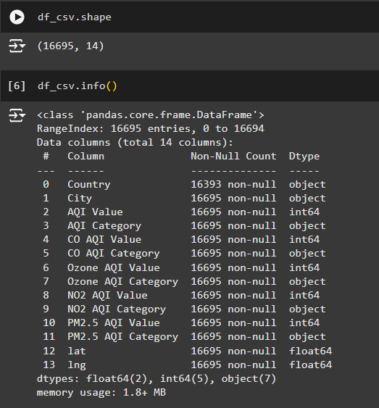

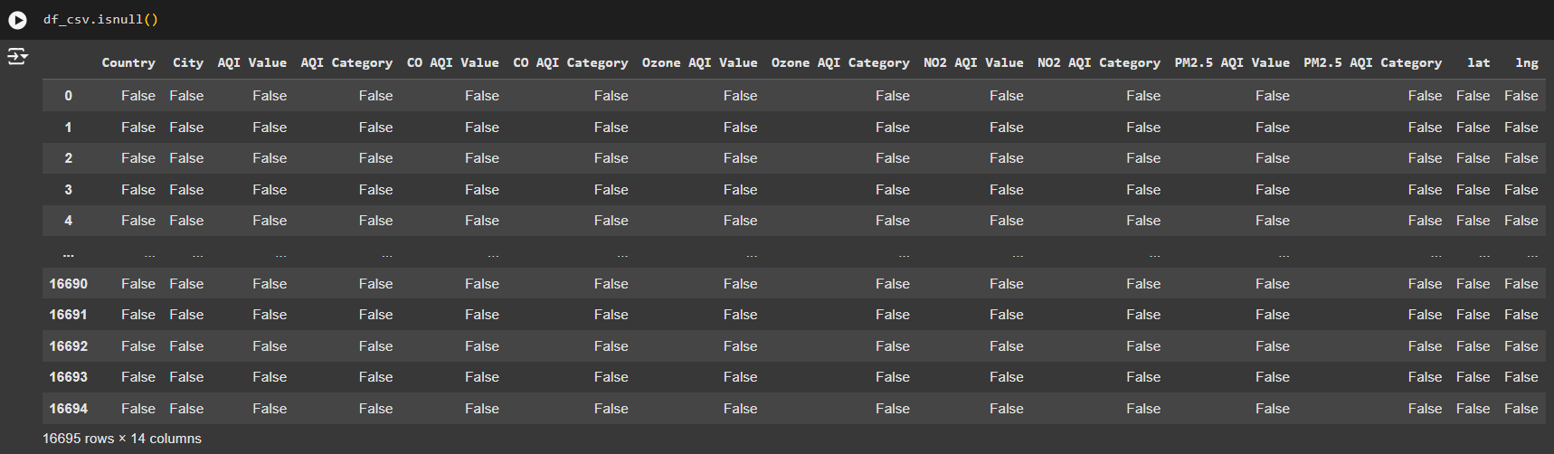
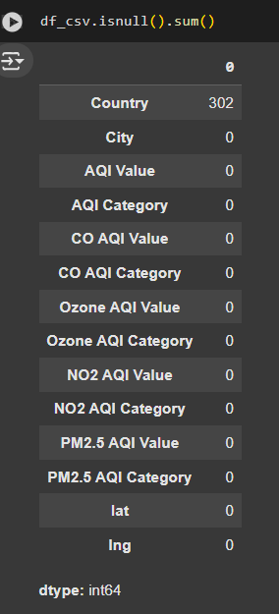
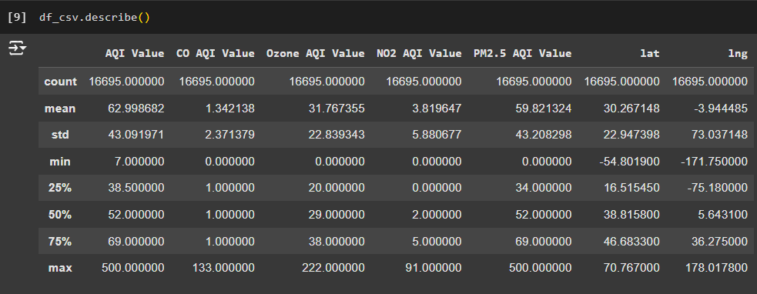

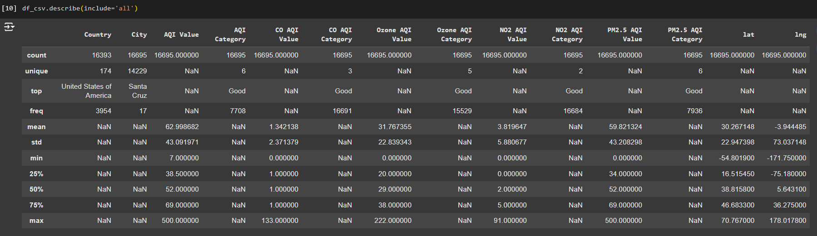

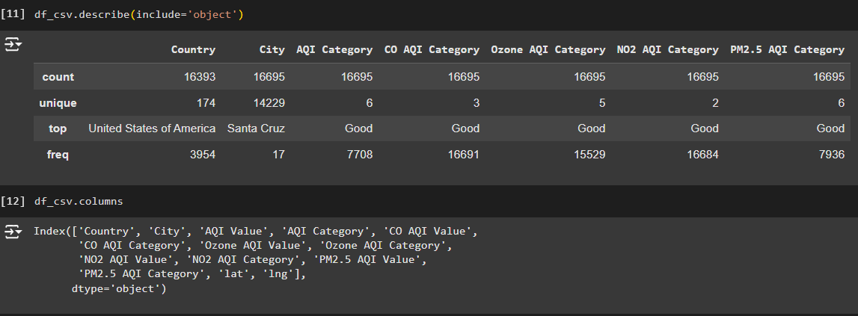

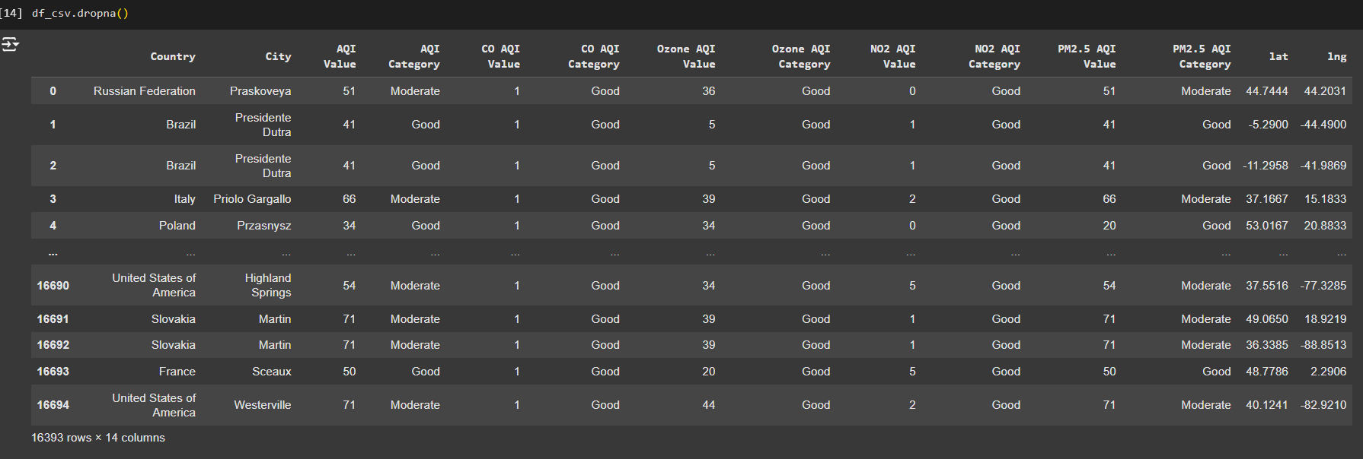

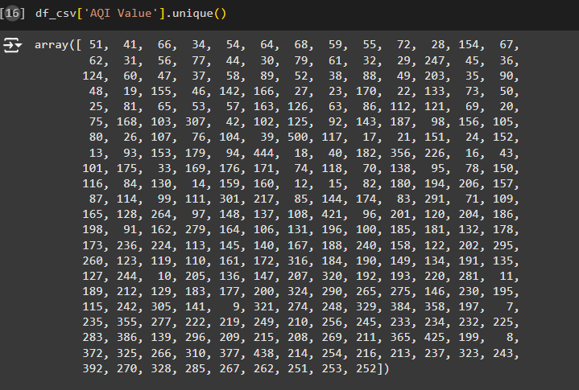

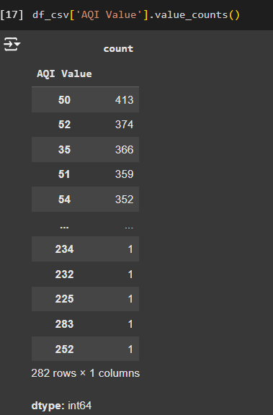

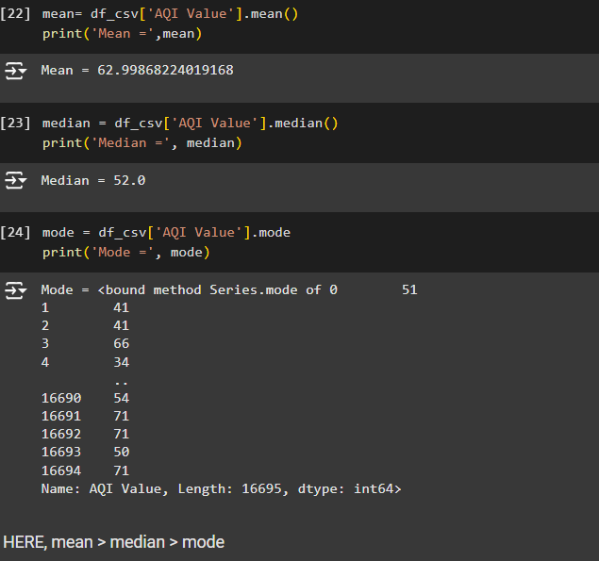

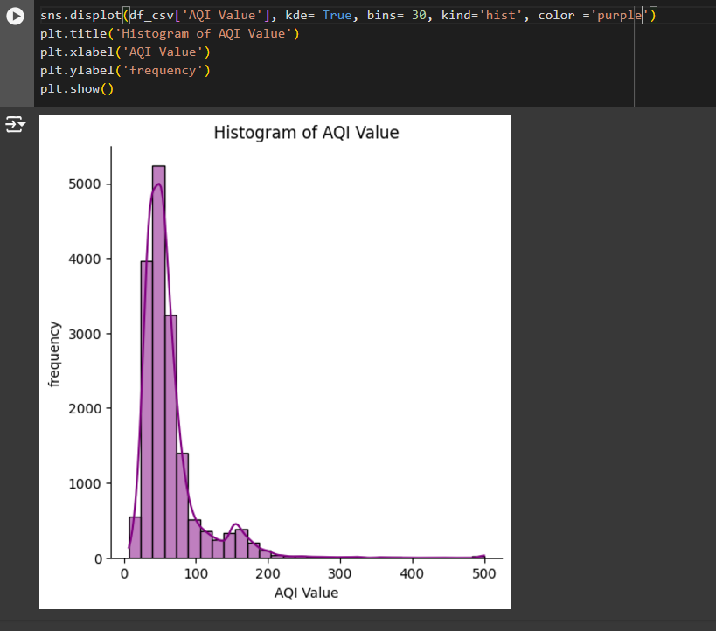
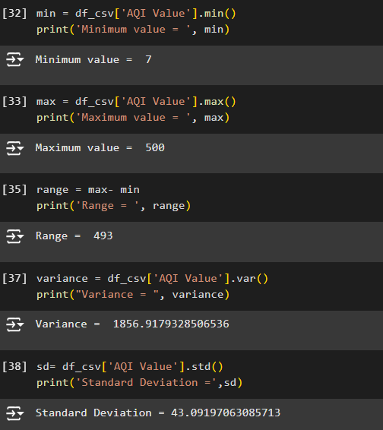

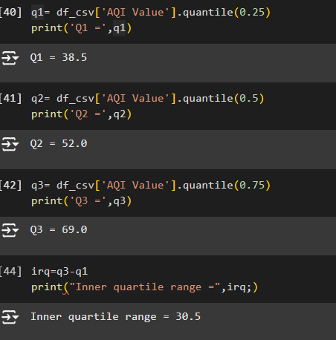

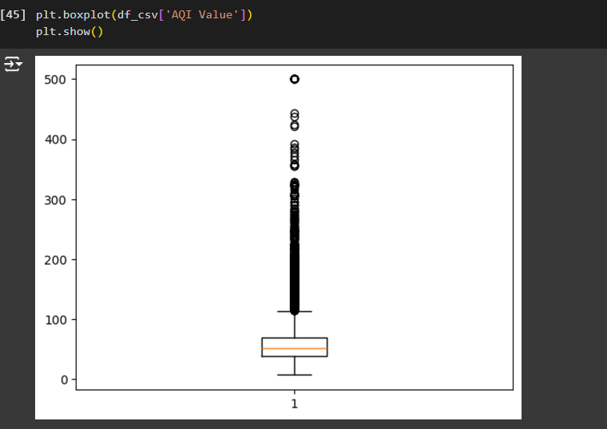

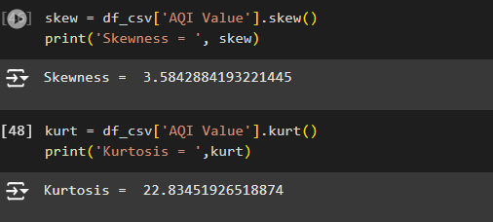
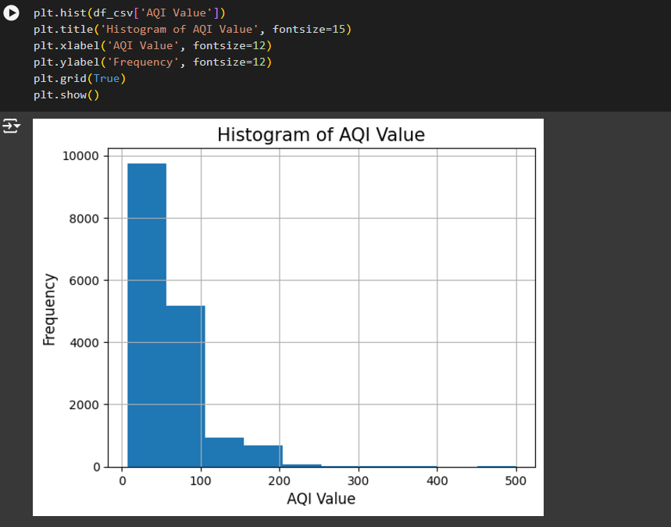
1.5 Conclusion
Hence, Anaconda Navigator and Jupyter Notebook, along with Python packages such as NumPy, Pandas, Matplotlib, and Seaborn, have been successfully downloaded and installed. Also, these data science packages were explored in Google Colab to perform descriptive statistical analysis.

